

**Adama Science and Technology University**

**School of Electrical Engineering and Computing**

**Course Title:** Fundamentals of Electrical Engineering

**Course Number:** PCE2101

**Lab:** Laboratory Experiment No - 3

**Title:**Network Theorems

**Prepared by:**

**Name ID No.**

**Submitted to:**Lecturer Tewdros

Date of conduction: November 25, 2016

Date of submission: December 2, 2016

**Acknowledgement**

We would like to acknowledge our lab assistant Tewdros for his support and explanation in the laboratory. Through the group work and experiment we were able to comprehend the topics that were raised and able to communicate with each other well.

**Theoretical Background**

The superposition principle states that the voltage across (or current through) an element in a linear circuit is the algebraic sum of the voltages across (or currents through) that element due to each independent source acting alone.

***Steps to Apply Superposition Principle:***

1. Turn off all independent sources except one source. Find the output (voltage or current) due to that active source using the techniques you know (like voltage divider rule, current divider rule and so forth).

2. Repeat step 1 for each of the other independent sources.

3. Find the total contribution by adding algebraically all the contributions due to the independent sources.

Thevenin’s theorem states that a linear two-terminal circuit can bereplaced by an equivalent circuit consisting of a voltage source *V*Th inseries with a resistor *R*Th, where *V*Th is the open-circuit voltage at theterminals and *R*Th is the input or equivalent resistance at the terminalswhen the independent sources are turned off.

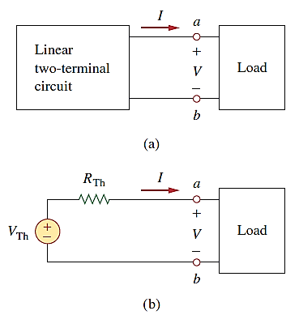

***Figure: Replacing a linear two-terminal circuit by its Thevenin equivalent: (a) original circuit, (b) the Thevenin equivalent circuit.***

To apply this idea in finding the Thevenin resistance, we need to consider two cases.

■**CASE 1:**If the network has no dependent sources, we turn off all independent sources. Rth is the input resistance of the network looking between terminals *a* and*b*.

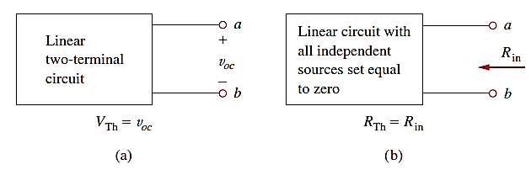

***Figure: Finding Vth and Rth***

■**CASE 2:**If the network has dependent sources, we turn off all independent sources. As with superposition, dependent sources are not to be turned off because they are controlled by circuit variables. We apply a voltage vo source at terminals *a* and *b* and determine the resulting current io. Then Rth = vo/io. Alternatively, we may insert a current source io at terminals *a*-*b* and find the terminal voltage vo. Again Rth = vo/io. Either of the two approaches will give the same result. In either approach we may assume any value of vo and io.

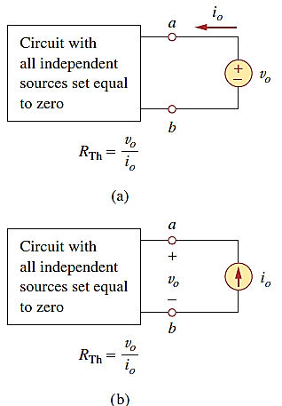

***Figure: Finding RTh when circuit has dependent sources.***

**Lab – 3: Network Theorems**

**Objectives:**

* To verify super position theorem.
* To verify Thevenin’s theorem.

**Apparatus Used:**

* 3 Fixed Resistors of different values
* 2 DC power supply

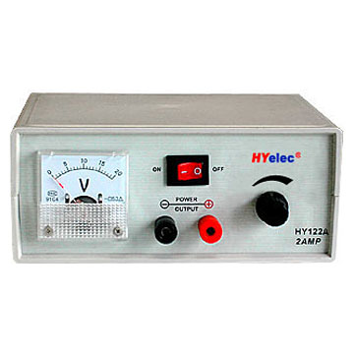Figure 3: DC power source

* Connectors
* 2 Digital Multimeter (DMM)



**Figure 4: Digital Multimeter**

**Procedures**

1. **Super Position Theorem**
   1. We first received three different resistors and placed them on a good surface. Then we measured their resistance.
   2. Then after we adjusted the first power supply (V1) to 15V and the second power supply (v2) to 10V.
   3. Following the above we constructed a circuit containing one resistor connected in series to a power source and two resistors connected in parallel to another source al found in a single circuit.

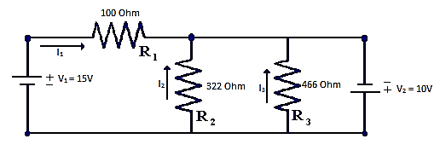

***Figure 1: Circuit for Experiment super position theorem***

* 1. Thereafter by applying superposition theorem we calculated the currents and voltages found at each resistors using the theorem.
  2. Then to apply superposition theorem practically we had to disconnect one of the voltages at a time and observe their individual effect. So first we disconnected V2 (10V) and measured each resistors current and voltage. After completing this we disconnected V1 (15V) and found the voltage and current across each resistor due to this power source.
  3. Then we connected both sources at the same time and measured the current and voltage across each resistor due to the two sources combined.

1. **Thevenin’s Theorem**
   1. Since only one power supply is needed for this part of the experiment we used only the V1 (15V) power supply.
   2. Then we constructed a circuit the same as before, except this time we removed the second power source (V2 = 10V).

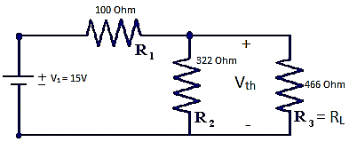

***Figure 2: Circuit for Experiment of Thevenin theorem***

* 1. By taking the third resistor as Load resistor we calculated the Thevenin resistance and voltage by using the theorem.
  2. Before transforming the circuit to the Thevenin equivalent circuit as shown on figure 3, we measured the voltage and current on the load resistor (R3).
  3. Then when we were doing the practical part of the experiment, we omitted the power source and at the two ends of the wires where the power source was supposed to be we attached our meter and measured the Thevenin resistance.
  4. Then we measured the Thevenin voltage which we can obtain by measuring the voltage at the second resistor.
  5. Following the above we transformed the first circuit into a circuit containing out Thevenin resistance Thevenin voltage as a source and the load resistor.

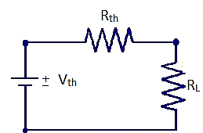

***Figure 3: Thevenin Equivalent Circuit***

* 1. Finally we measured the voltage and current found at the load resistor and compared them with the one we got before transforming to the Thevenin equivalent circuit.

**Result and Discussion**

From the experiments we have done we have obtained the following measurements.

|  |  |  |  |  |  |  |  |
| --- | --- | --- | --- | --- | --- | --- | --- |
| Super position Theorem | | | | | | | |
|  | It(mA) | I1(mA) | I2(mA) | I3(mA) | V1(V) | V2(V) | V3(V) |
| Calculated Value | 0.302 | 0.25 | 0.031 | 0.025 | 25 | 10 | 10 |
| Measured Value due to V1 | 0.15 | 0.15 | 0 | 0 | 14.8 | 0 | 0 |
| Measure Value due to V2 | 0.153 | 0.10 | 0.031 | 0.025 | 10.8 | 10.5 | 10.4 |
| Measured value due to both sources | 0.301 | 0.23 | 0.033 | 0.025 | 24.8 | 10.1 | 10.3 |

|  |  |  |  |  |  |  |  |
| --- | --- | --- | --- | --- | --- | --- | --- |
| Thevenin Theorem | | | | | | | |
|  | Rth() | Vth(V) | IL (mA) | VL(V) | V1(V) | V2(V) | V3(V) |
| Calculated Value | 76.3 | 11.44 | 75 | 9.83 | 5.16 | 9.83 | 9.83 |
| Measured Value of Figure 2 | 76.9 | 11.43 | 75.2 | 9.81 | 5.15 | 9.81 | 9.81 |
| Measure Value of Figure 3 | - | - | 75.1 | 9.81 | - | - | - |

**Conclusion**

We have observed the following points about the super position theorem:

* The current and voltages across each resistors are the summation of the voltages that occur because if the two power sources acting alone.
* The total current of the circuit is found where both power sources have total current.

We have observed the following points about the Thevenin theorem:

* The voltage at the load resistor and R3are similar to each other, meaning that the values we obtain on the Thevenin equivalent circuit are correct.
* The total current is similar on both figure 2 and figure 3.
* The Thevenin theorem provides an easier way to compute the voltage and current of one load.

**References**

* Fundamentals of Electric Circuits, C. K. Alexander and M. N. O. Sadiku

**Thank you!!!**